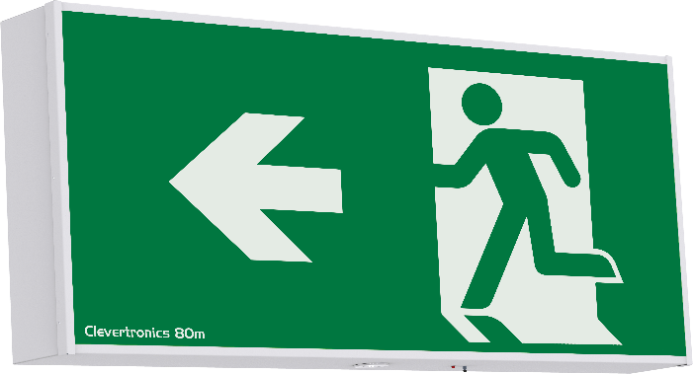

ENTER PROJECT INFORMATION HERE

|  |  |
| --- | --- |
| **PRODUCT INFORMATION** | |
| Part Number | CGELED-80-WM-RL |
| MIC | AUA02310240001 |
| Description | LP Premium Wall Mount Gigantor Exit, 80 metre Viewing Distance,  Enabled with Clevertest Plus |
| Construction | Powder coated Metal Frame with Acrylic Diffuser |
| Mounting | Wall Mount, Single-Sided |
| Dimensions L x W x H | 1305mm x 170mm x 560mm |
| Weight | 21kg |
| Operating Mode | Maintained |
| Testing System | Clevertest Plus Enabled (Not activated by default) |
| Battery | Lithium Iron Phosphate,1 x 3.2V 6400mAh (Exit), 1 x 6.4V 3200mAh (EM) |
| Charging Method | Intelligent Current Limited Constant Voltage |
| Diffuser | Running Man, Arrow Left (must specify diffuser combination) |
| Lamp(s) | Exit: LED strip module, 4,000K natural white, Ra>80,  LED Lifetime: >100,000hrs (AS/NZS2293.3 LSL=39Y/00M), Ta 40°C  EM: 2 x 3W LED (Lifetime warranty on the Lamp head and loom Assembly) |
| Operating Voltage | 240V AC; 50Hz |
| Power Consumption | 23 Watts (Standby), 30 Watts (Max) |
| IP Rating | IP20 |
| Operating Temperature | 1˚C to 40˚C |
| AS2293 Classification | C0=D80 C90=D80 |
| Viewing Distance | 80m |
| Applicable Standards | AS/NZS3820, CISPR15, AS/NZS2293.3 |
| Compliance Marking (RCM) |  |
|  | |
| **REPLACEMENT PARTS** | |
| **PART NUMBER** | **DESCRIPTION** |
| 1550290 | BATT:LP 6.4V 3.2Ah.200mm lead.Stick.Brkt |
| 1550230 | BATT:LP 3.2V 6400mAh.200mm lead.Brkt. |
| 1330054 | LED Driver - LC 38w 500-700mA, 20-54V |
| 8002690 | PCA:LED Strip Argonaut Stand & tray,1.2m |
| 1100869 | Lifelight Pro Head Assembly, Ld:280mm,Rnd,LT,Gen 2 |
| AUM02370180001  CCPLED-38V120C-CKIT | LED Power Pack, 38V 120mA, LP, CTP |
| AUM02370050001  CLIFE-PRO-CKIT-NP | Lifelight Pro, Control Only, 530mm, NP, CTP, OWC |

The product details described in this document are current as at the version date of the document. We reserve the right to change product design, specifications

or materials (Specifications) as part of our continuous improvement program. Please confirm the applicable Specifications at the time of placing your order